**Screenshots and Detailed Information**

After logging into the GCP, here is the home page of the Project:

* Below displays the shortcut for the respective project for Quick access the tools.

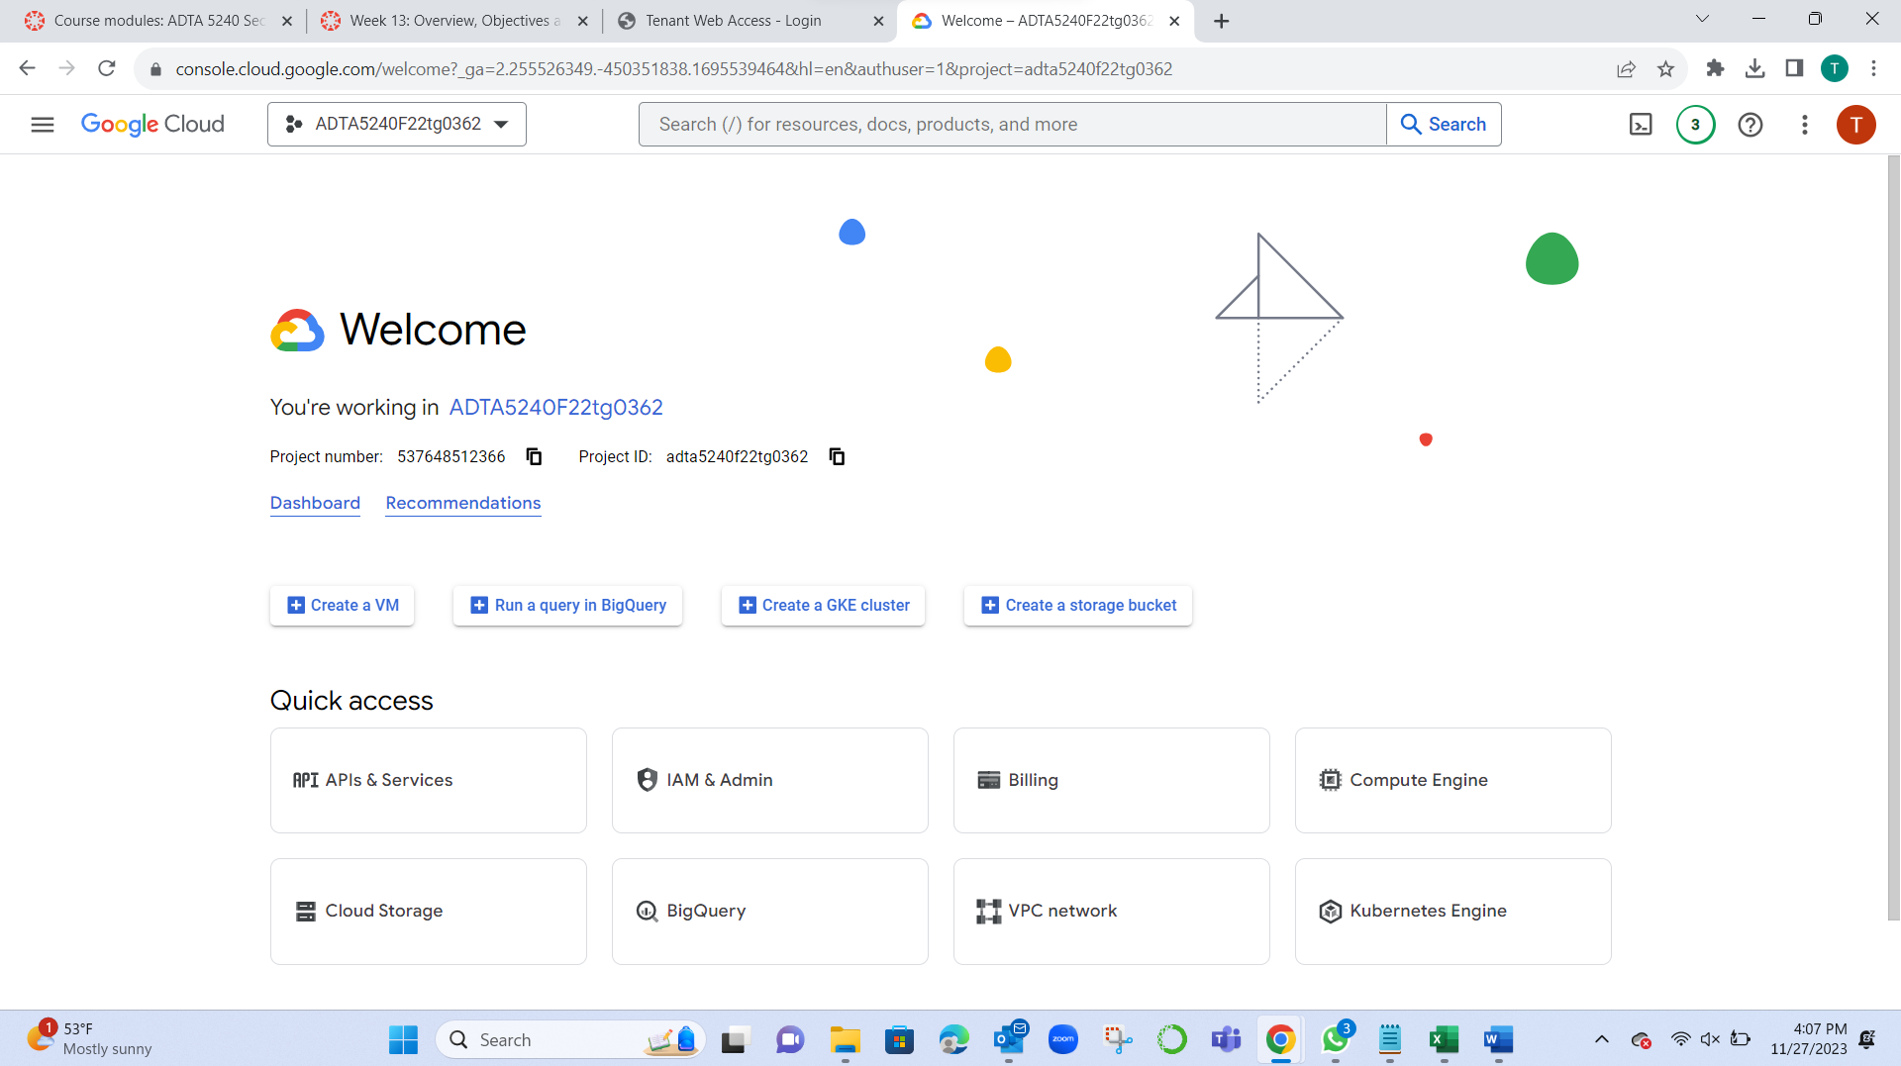

Created a bucket with the name final_project_indicators for the project.

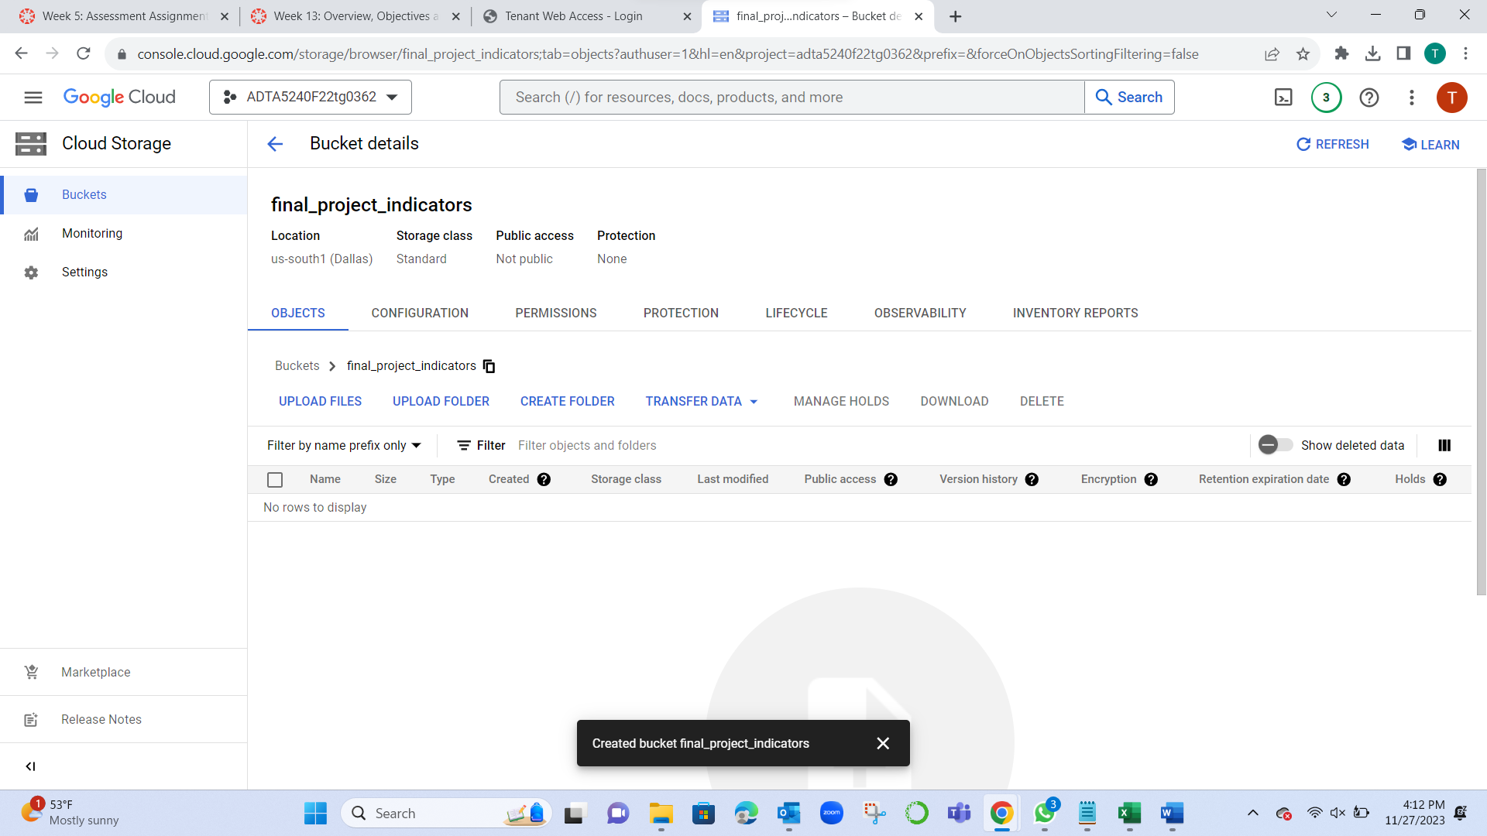

* Inside the Bucket after clicking new folder, we can name the folder and then upload the files Related to the project to it.
* Created a Folder Final/ to store dataset into it.

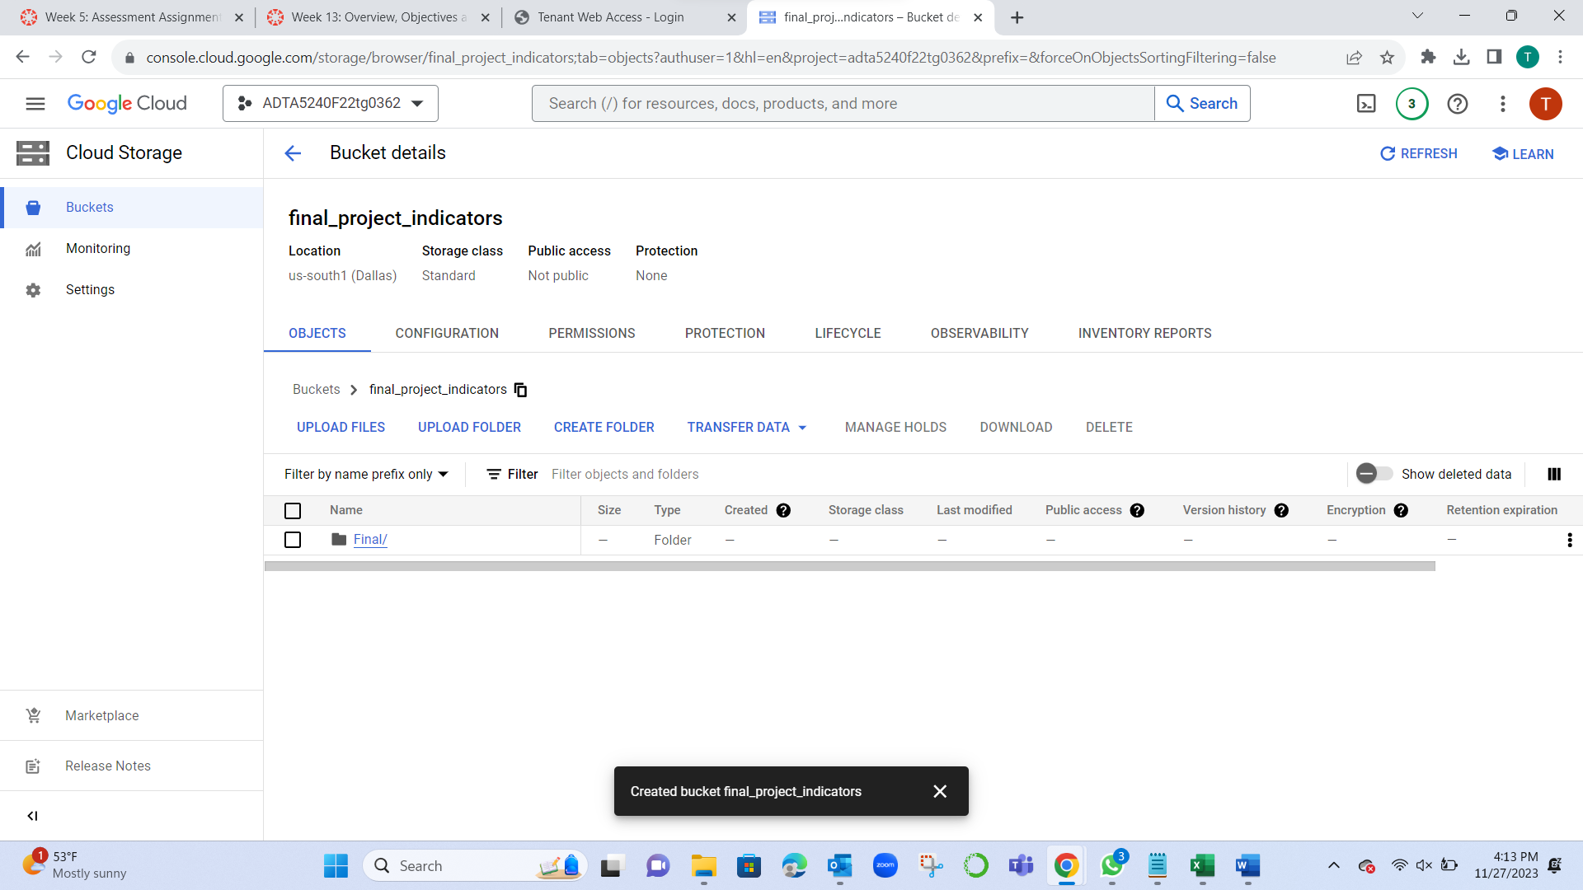

* Inserted Raw dataset to the Final Folder.
* The view 311 service requests for Fiscal year 2020-2021 and it has the data for service requests and raise complaints in the Dallas Region.

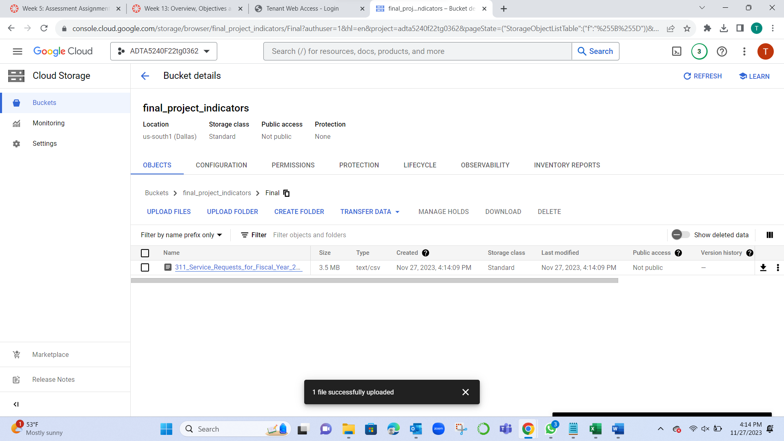

* Used Jupyter notebook to check Duplicate and missing values in the dataset.
* In python imported Pandas to work on Data frames.
* Performed basic steps for checking the fields and their data types description of the dataset.

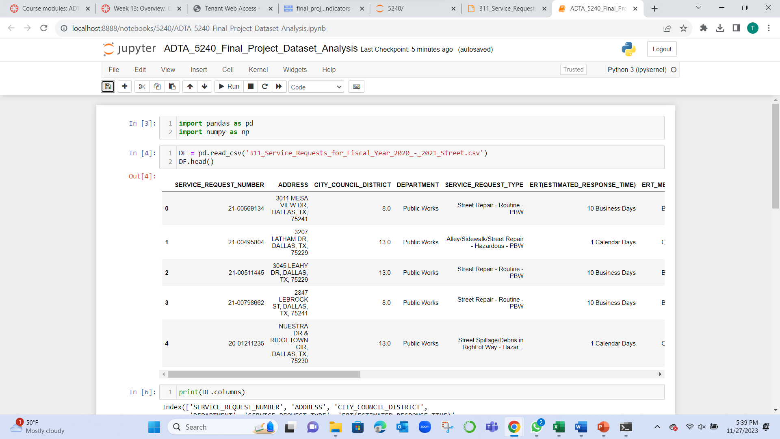

* The shape of the dataset is 10968 records and 17 attributes before cleaning.
* City council district has 23 missing values.
* ERT (Estimated_response_time) has 38 missing values.
* ERT_Measured_IN has 38 missing values.
* Outcome has 660 values.
* Here in the below service request type filtered with “street referral pickup – SAN”: ERT (Estimated_response_time) and ERT_Measured_IN are having NULL values.

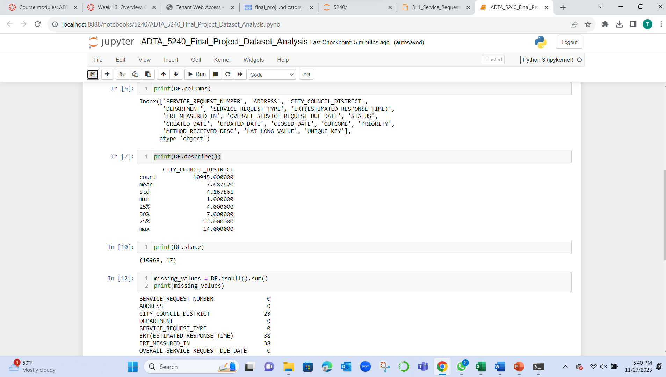

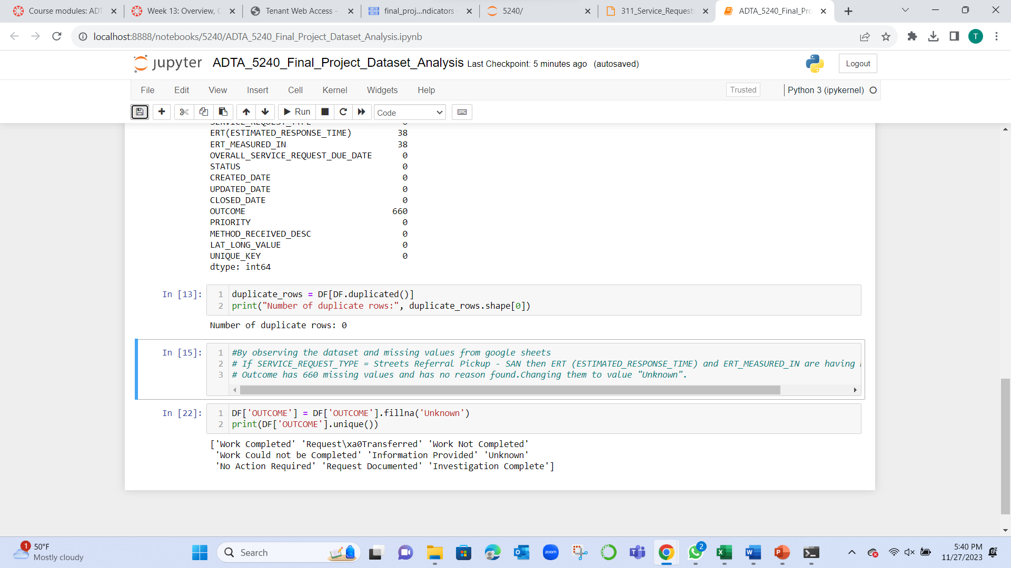

We have 660 blank values and those are replaced with ‘Unknown’ value.

**Application used: Jupyter Notebook(python)**

In the Open refine we have verified integer value and also sliced Latitude and Longitude to two separate columns and exported as Final_project_Indicators.

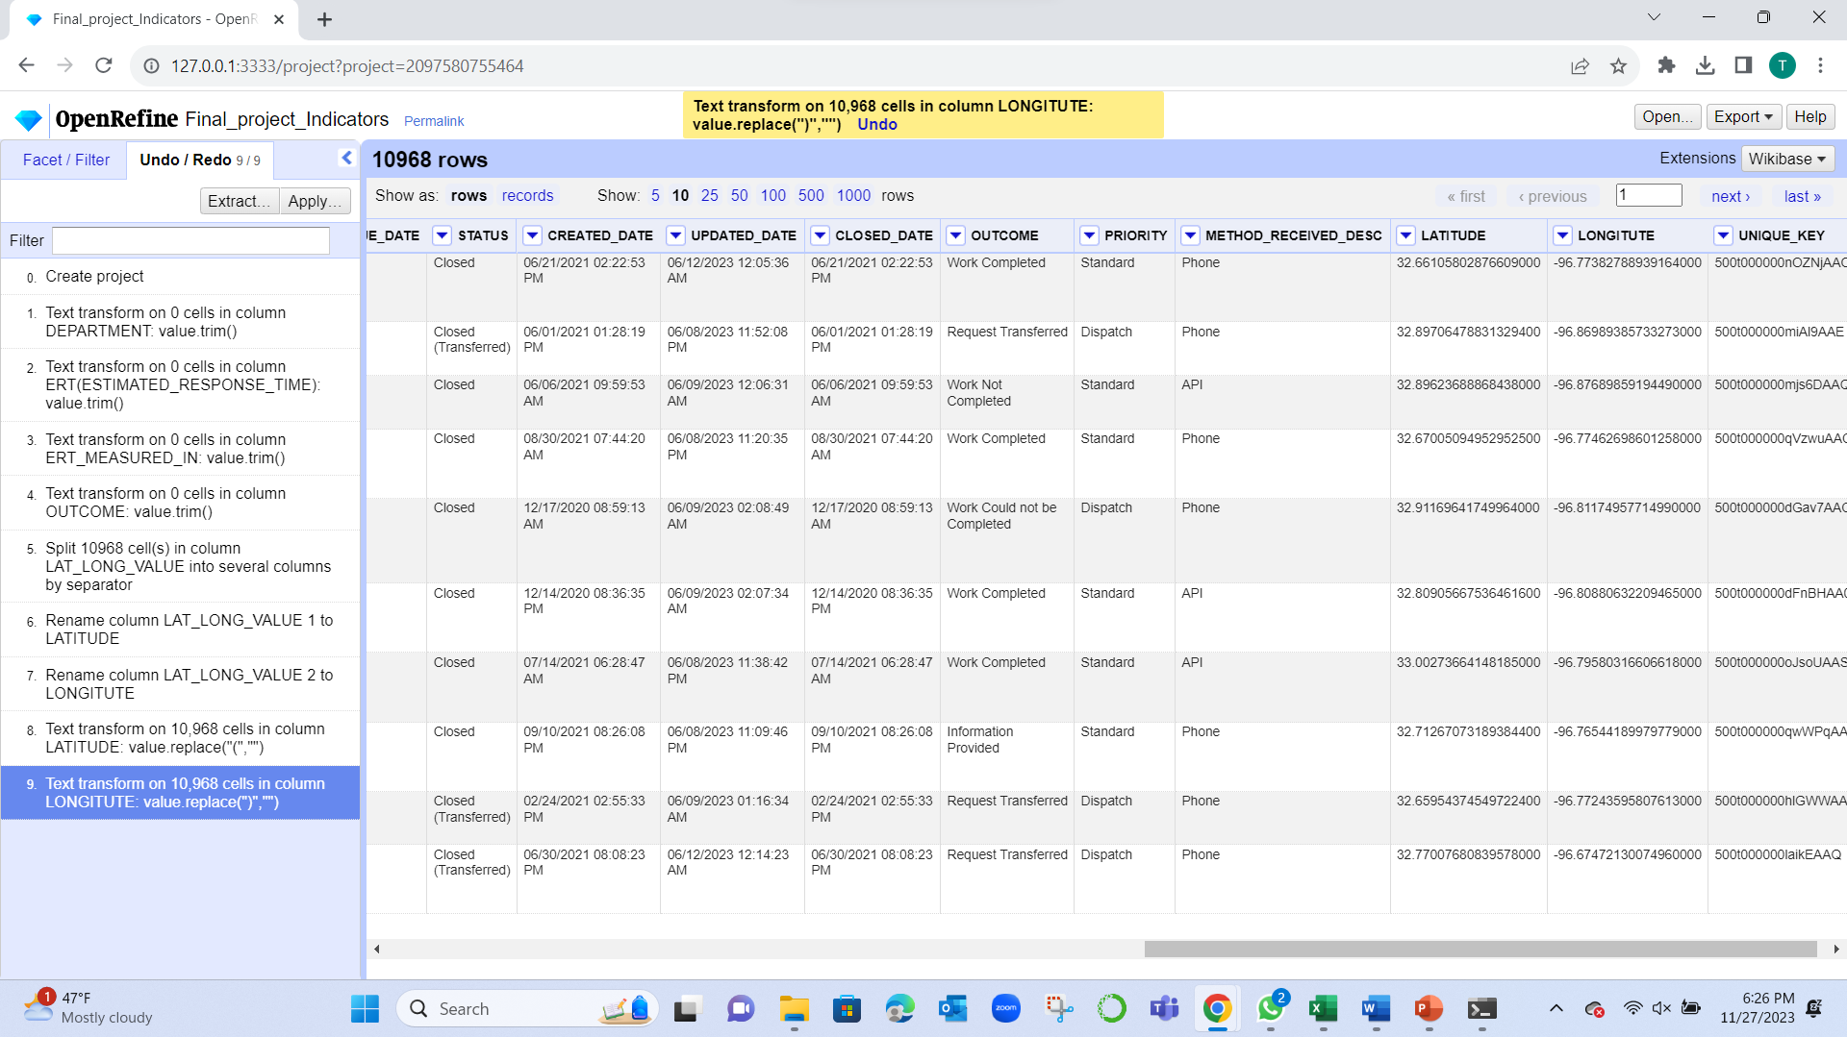

**Application used: Openrefine**

* Download or Export the Dataset from Openrefine and then using Upload files in the GCP bucket from local storage.
* Imported the Cleaned Dataset into the Bucket.

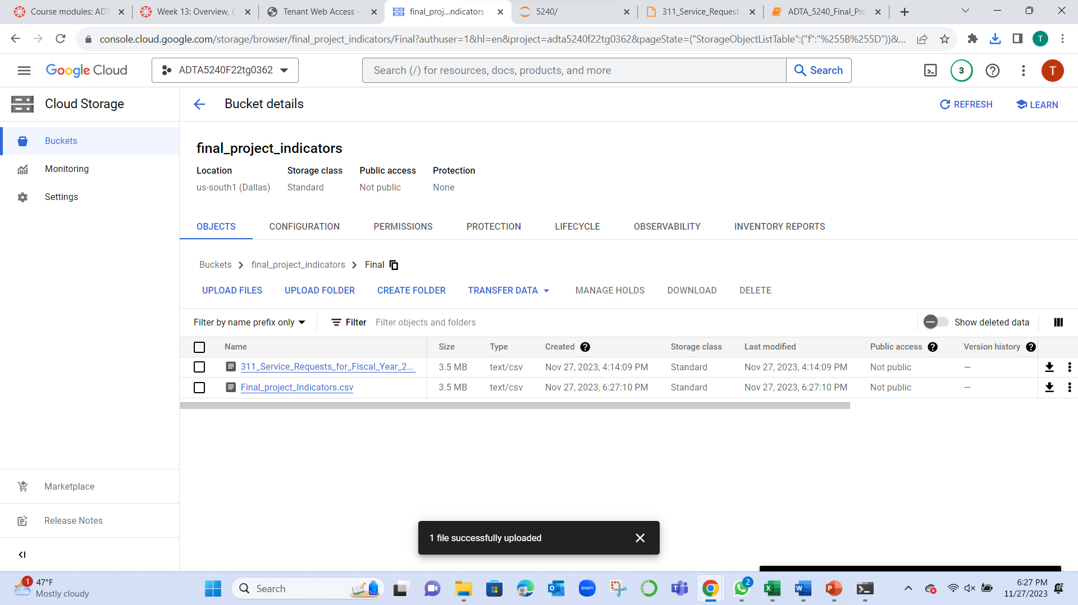

Here is the Information of the Dataset after inserted it into the Big Query

**Application: GCP BigQuery**

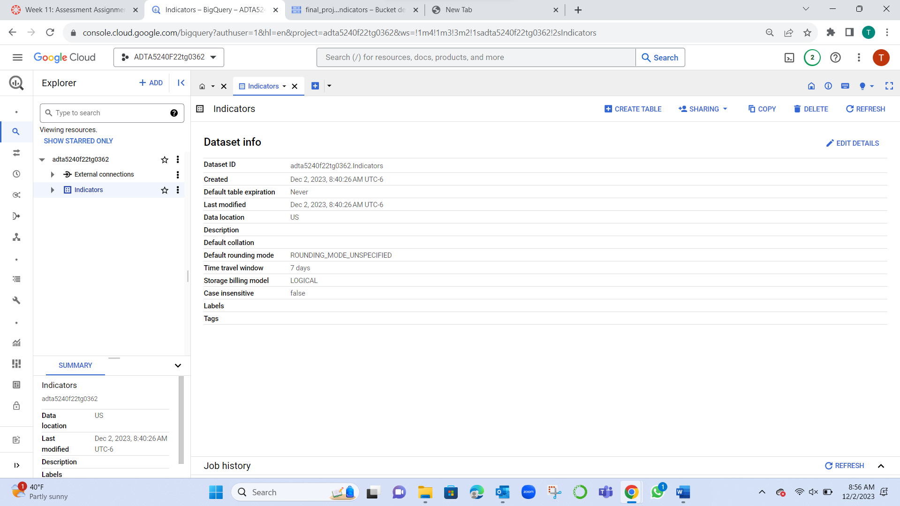

**Hadoop**

Created 1 Master node and 2 worker nodes in the cluster to the Final_project_Indicator bucket.  
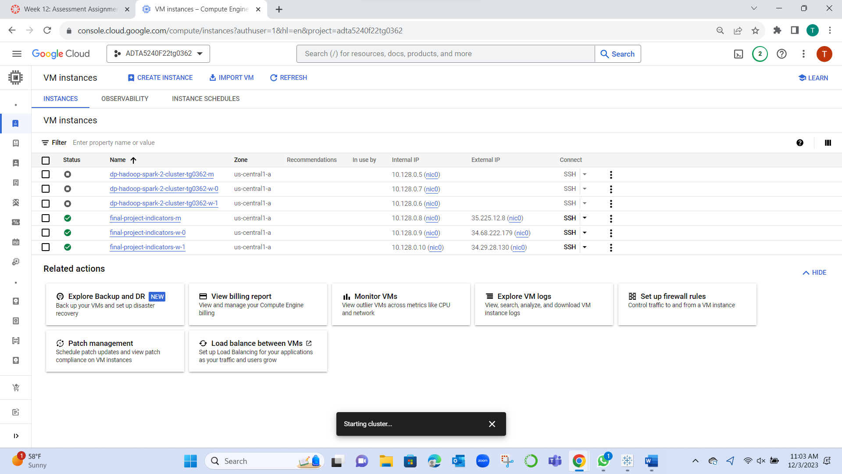

Using SSH : Setting the hdfs paths for Dataset to work on the Hive and Spark workspace.

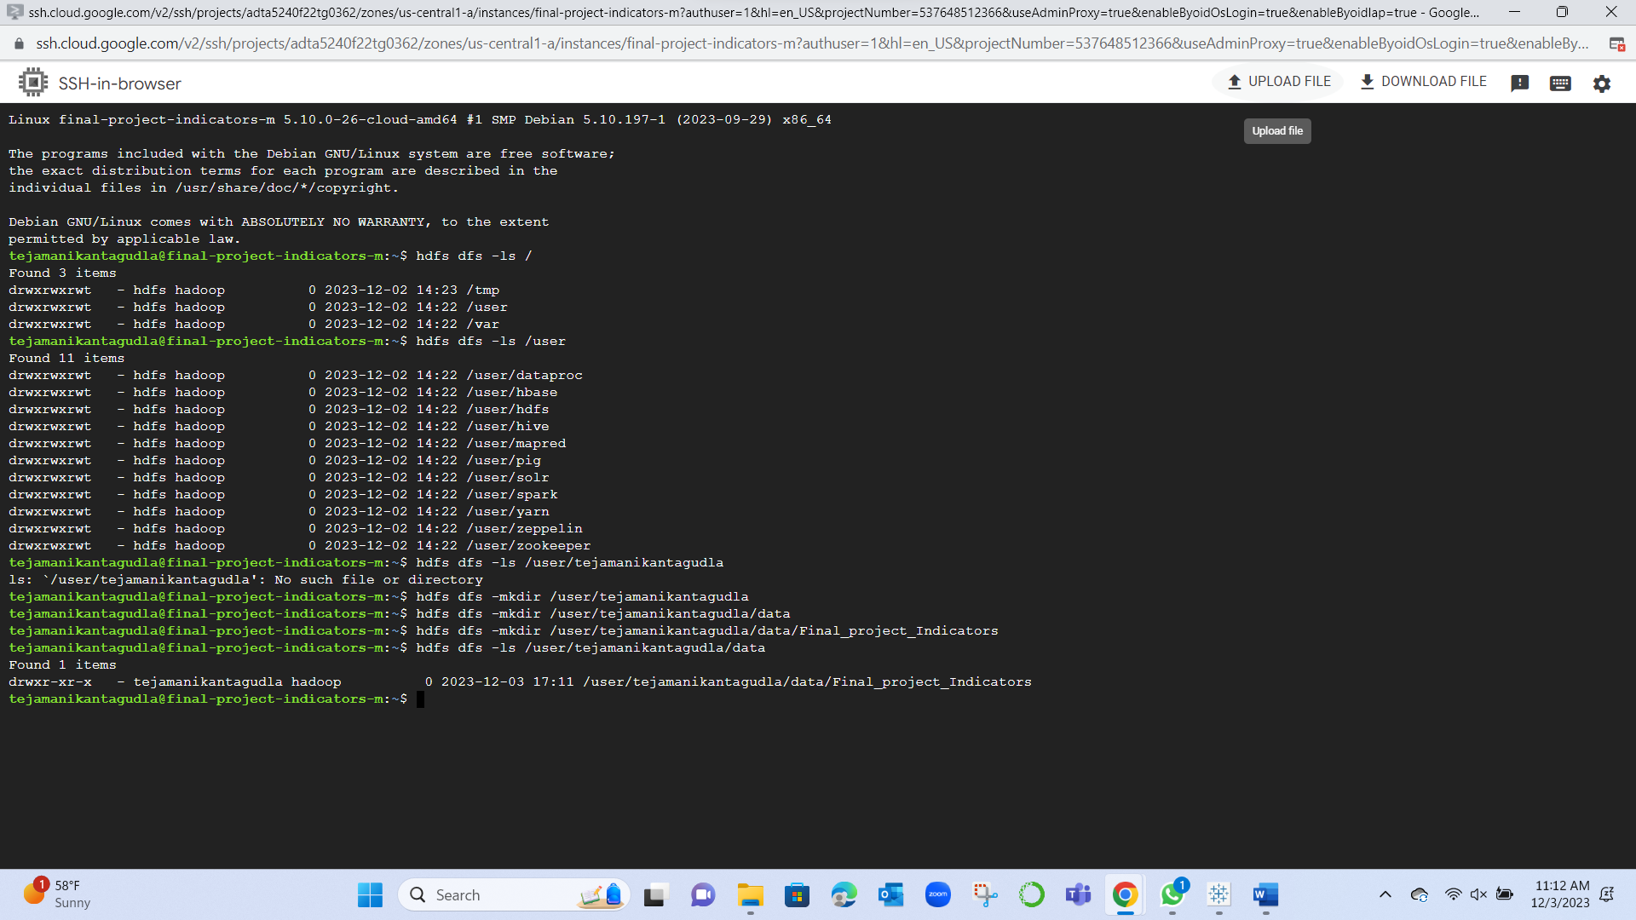

**Application used: Linux SSH**

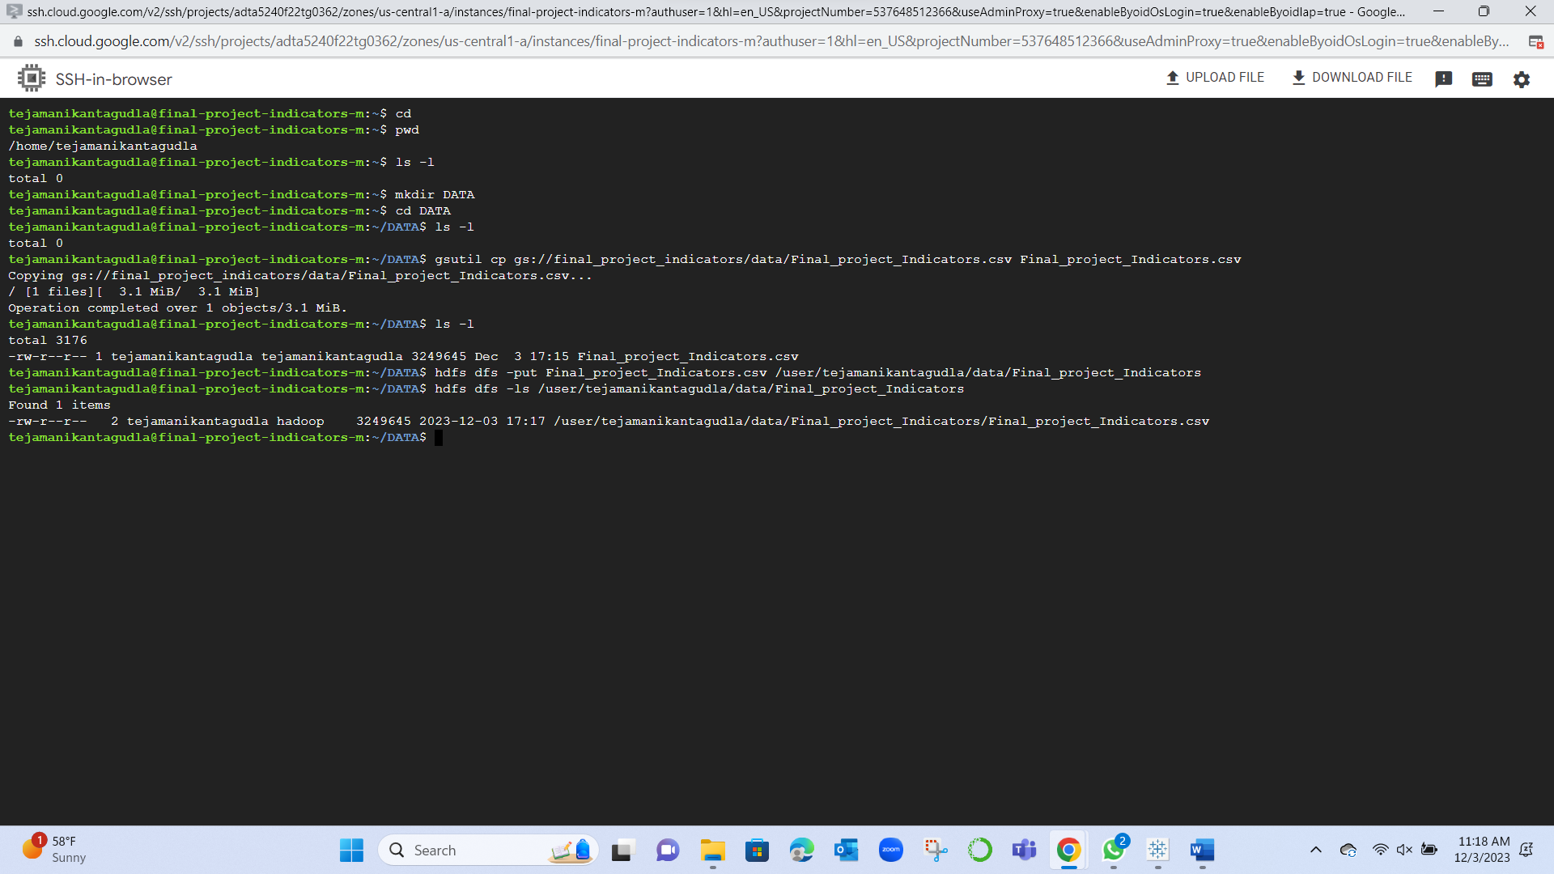

**Application used: Linux SSH**

Below is the attributes with datatypes generated in the Schema.

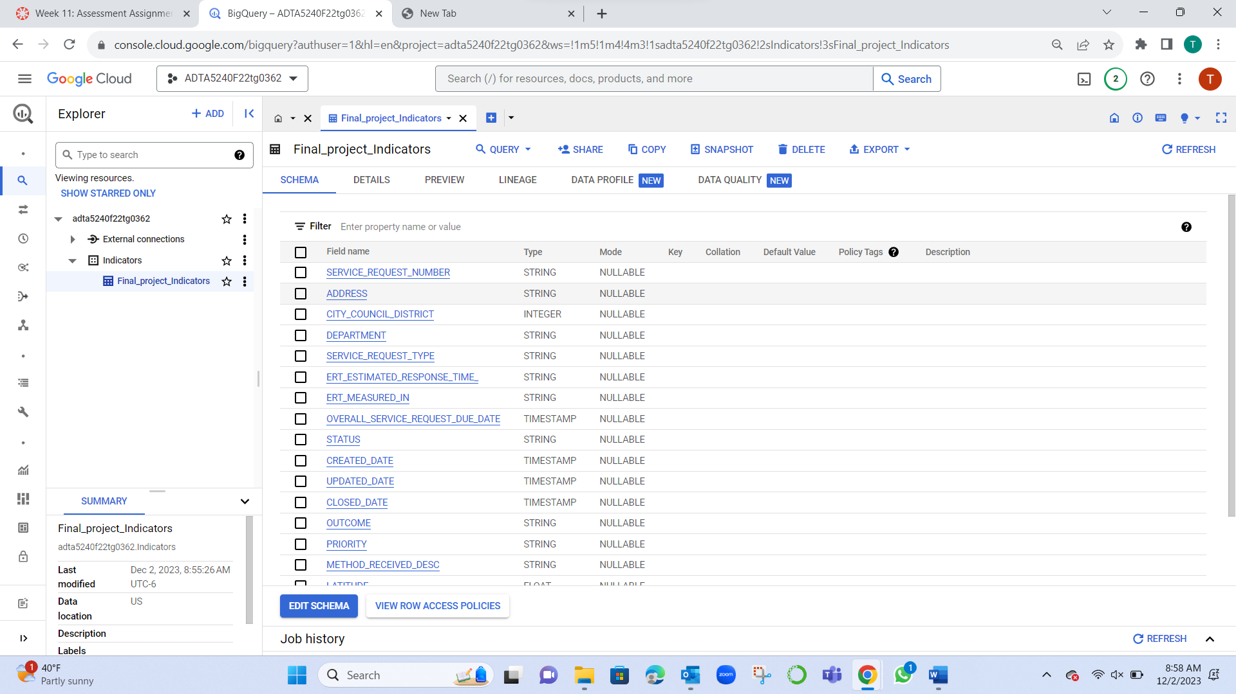

**Query 1:**

SELECT *

FROM `Indicators.Final_project_Indicators`

WHERE EXTRACT(YEAR FROM CREATED_DATE) = 2021

LIMIT 100;

It results in first 100 records with filtered created date 2021.

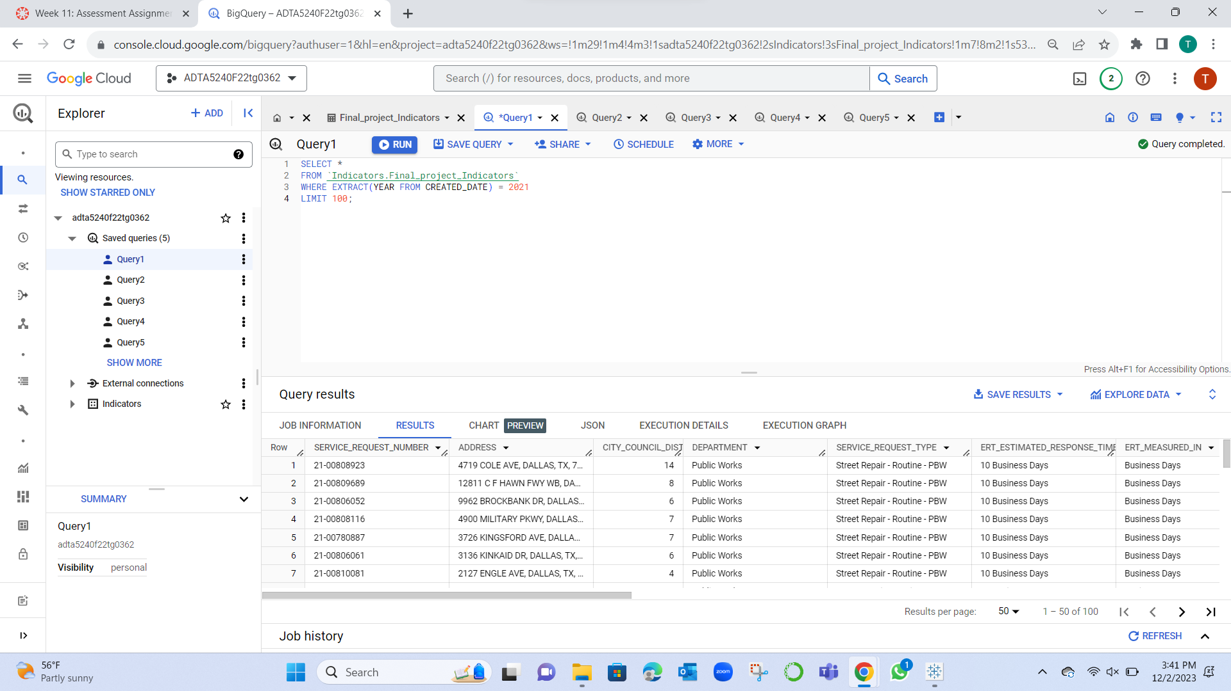

**Query 2:**

SELECT SERVICE_REQUEST_TYPE, COUNT(*) as Total

FROM `Indicators.Final_project_Indicators`

GROUP BY SERVICE_REQUEST_TYPE

ORDER BY Total DESC;

Street Repair-Routinue-PBW (4452) is the highest service request type.

Traffic-Street Closure_TRN (11) is the lowest service request type.

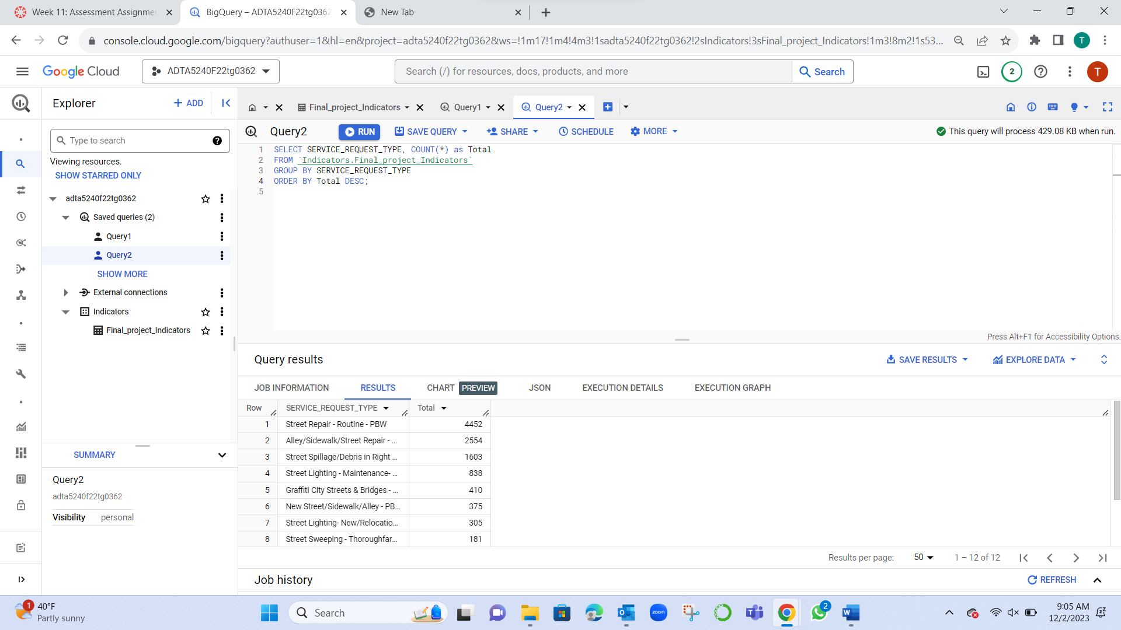

Query 3:

SELECT * FROM `Indicators.Final_project_Indicators`

WHERE METHOD_RECEIVED_DESC = 'API';

Result: Query resulted in 3636 records.

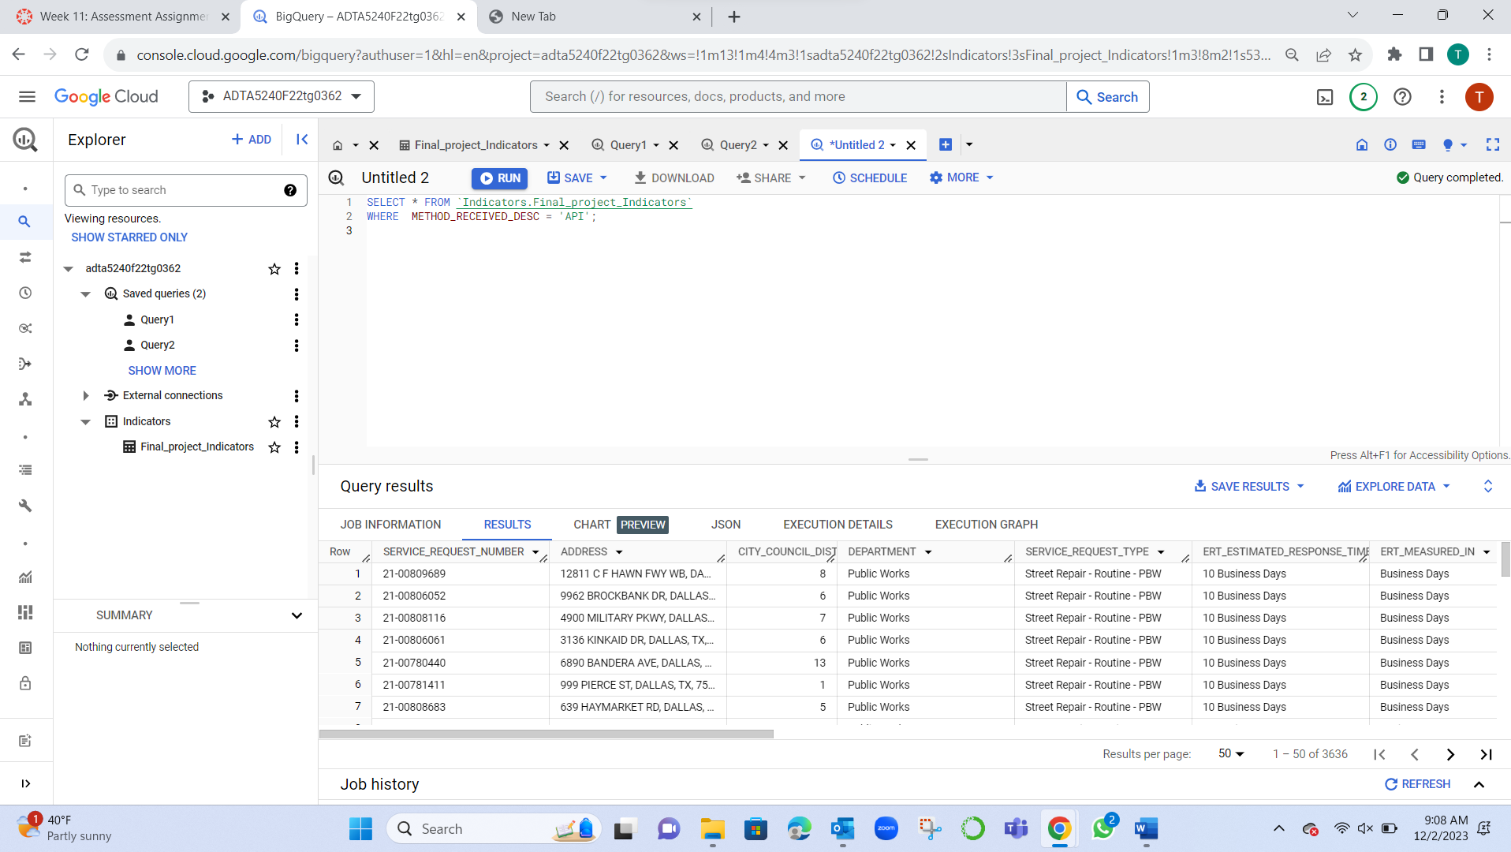

Query 4:

SELECT * FROM `Indicators.Final_project_Indicators`

WHERE STATUS = "Closed" and METHOD_RECEIVED_DESC = "Phone";

Result: Query resulted in 4787 records.

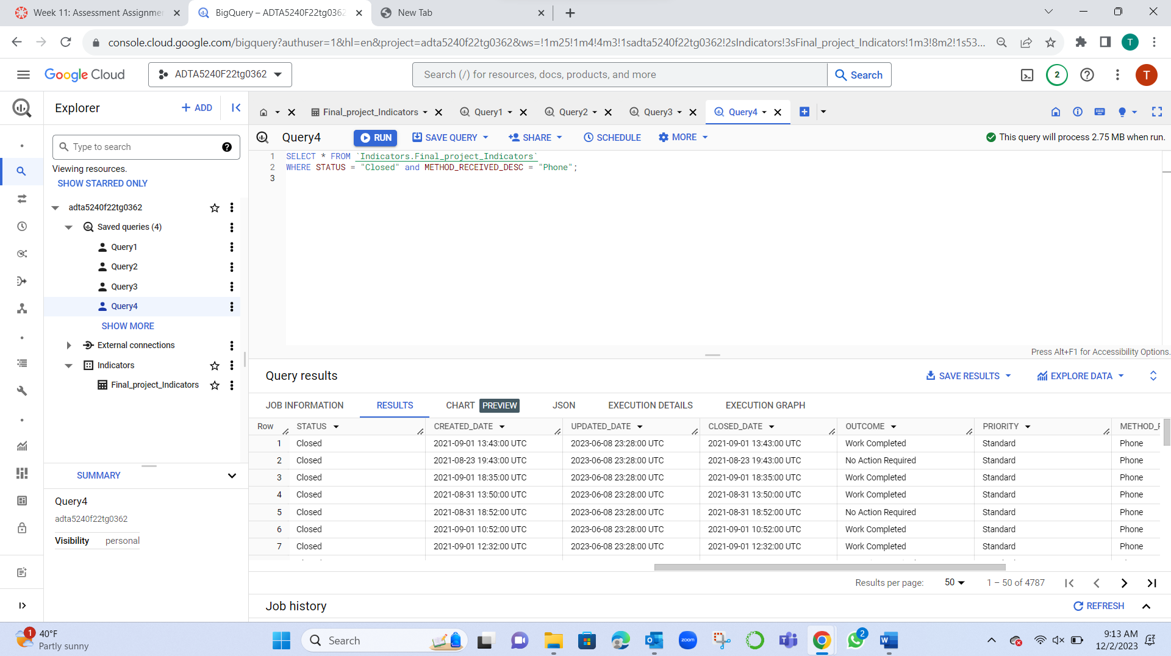

Query 5:

SELECT DEPARTMENT, AVG(CITY_COUNCIL_DISTRICT) as AverageValue

FROM `Indicators.Final_project_Indicators`

GROUP BY DEPARTMENT;

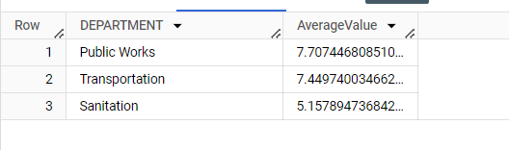

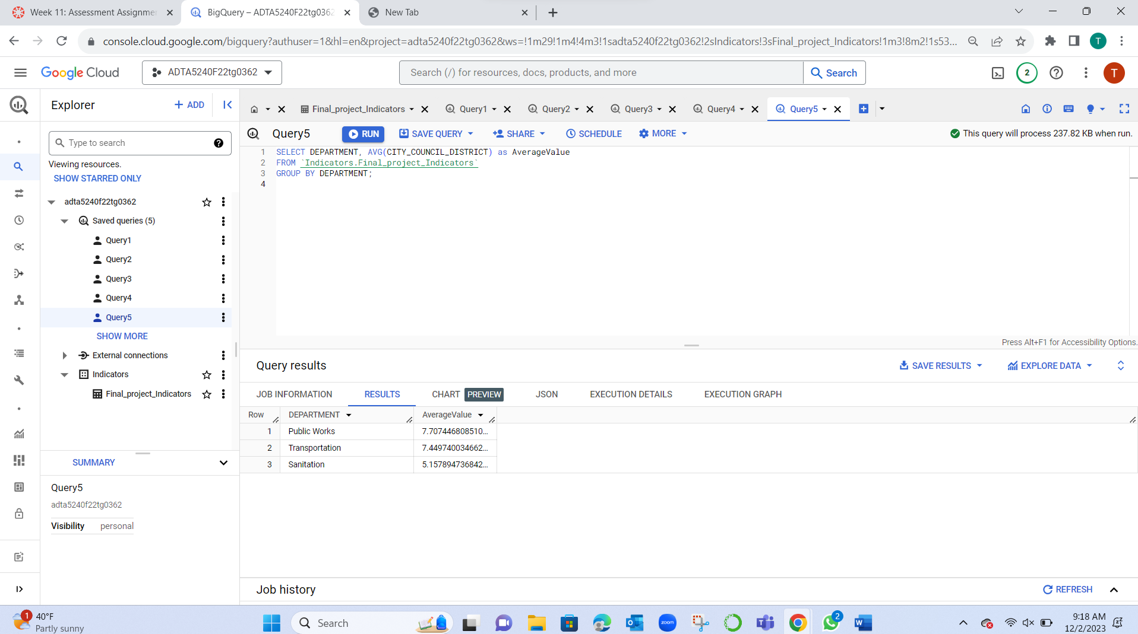

**Application used: GCP BigQuery**

**Tableau:**

1. It displays the decreasing order of service request type.

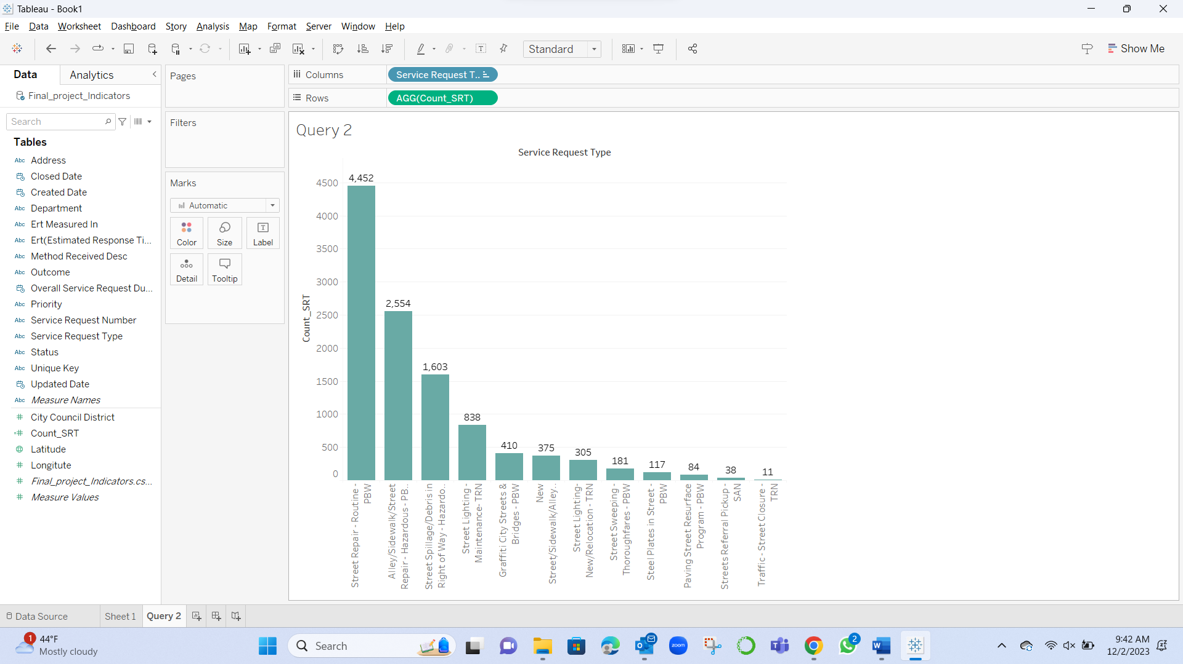

1. 3636 records are filtered with method received description of ‘API’.

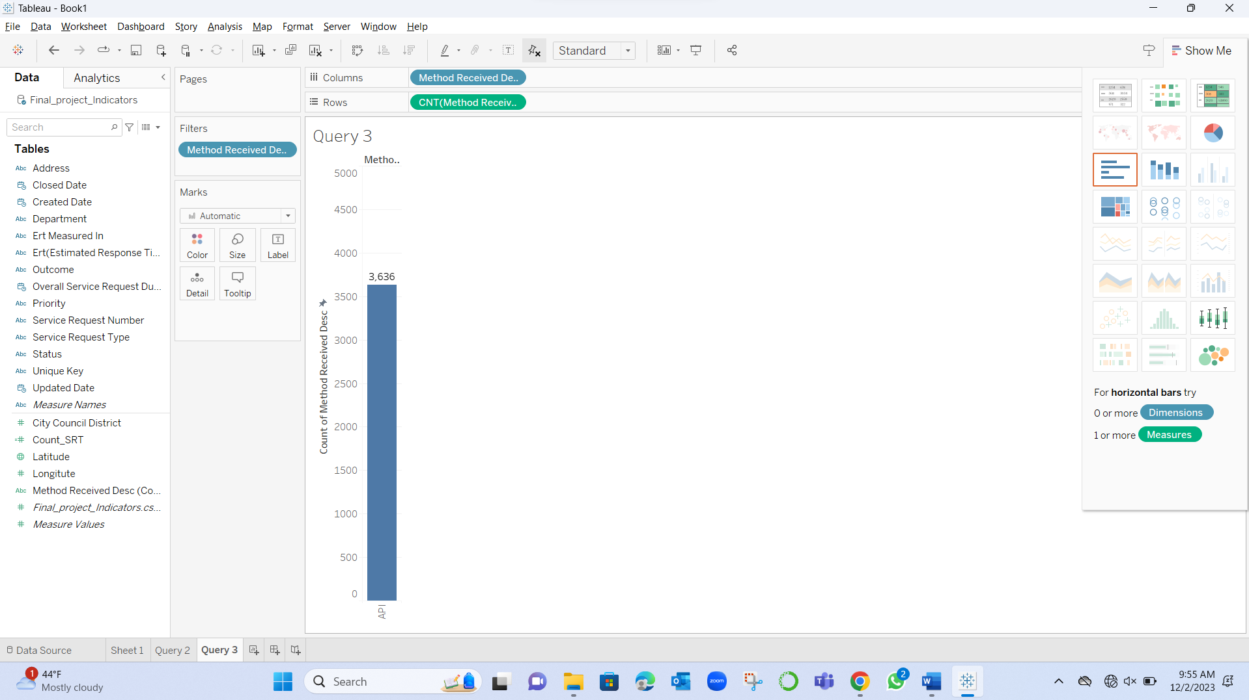

1. 4787 records are filtered with status “closed” and method received description “phone”.

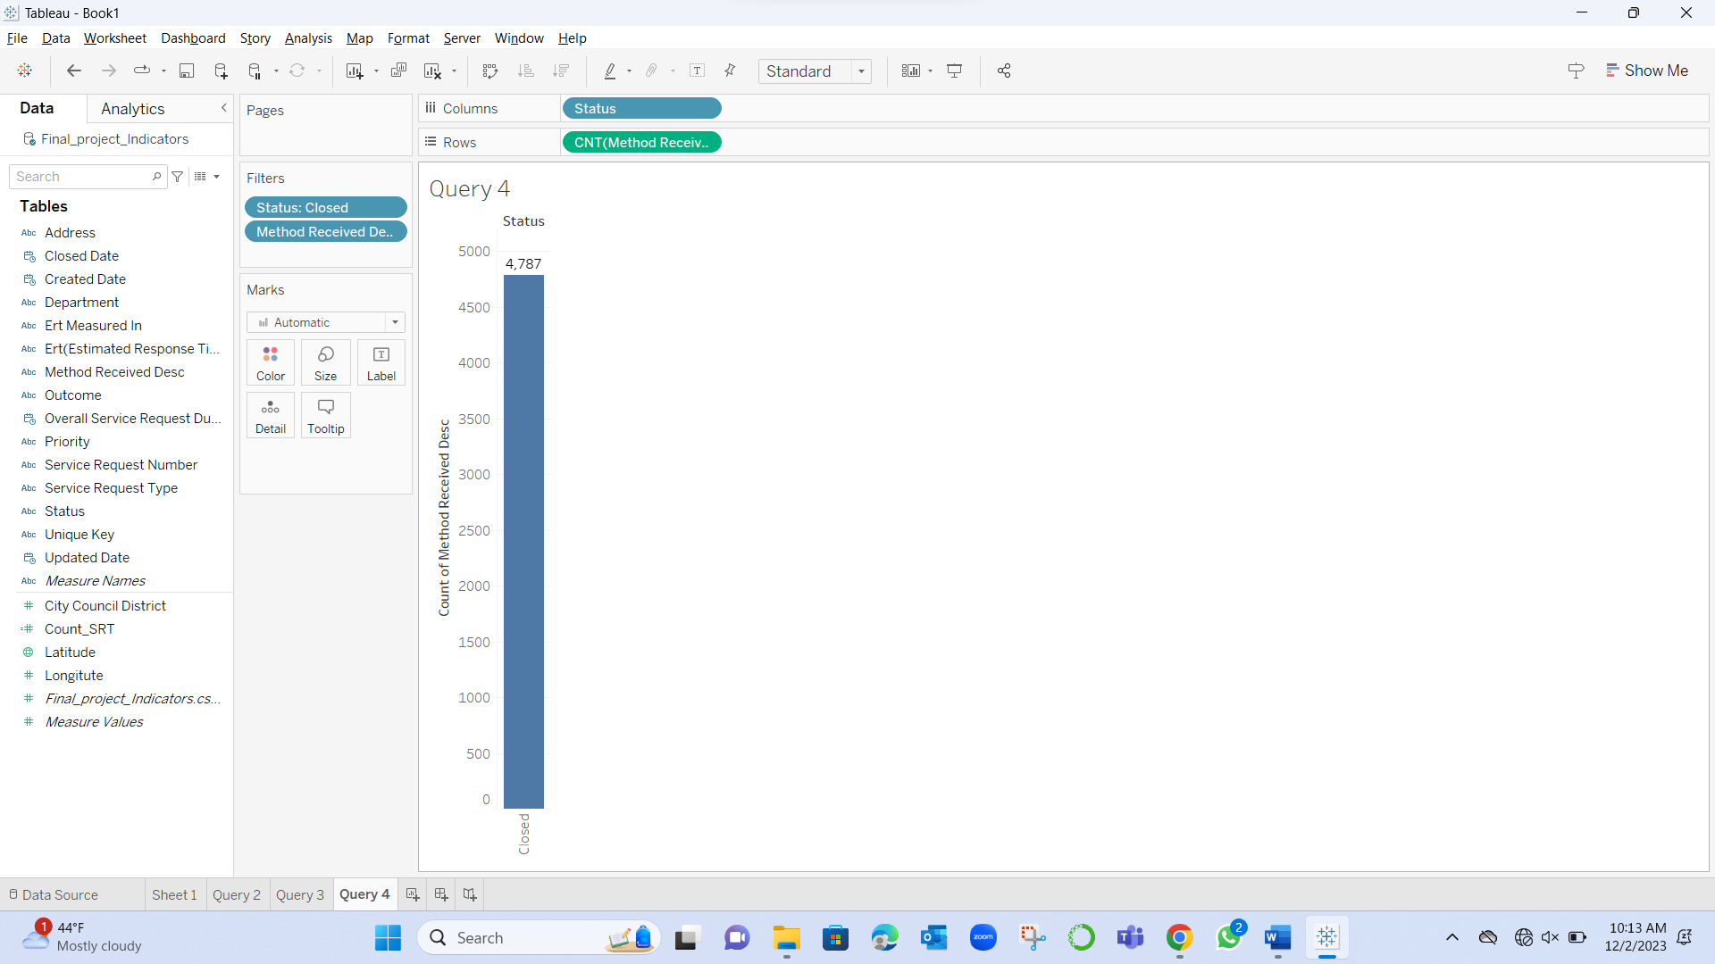

Calculating Average and Sum of each type in Department.

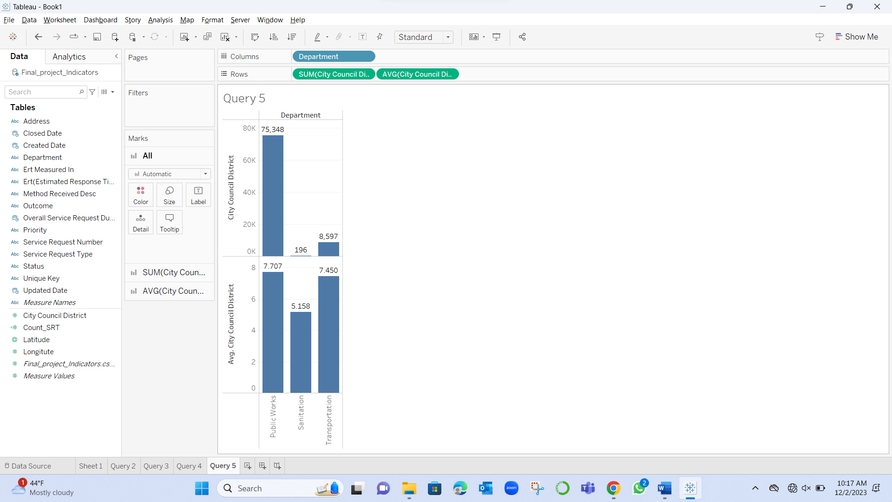

Latitude and Longitude are in the Dallas region.

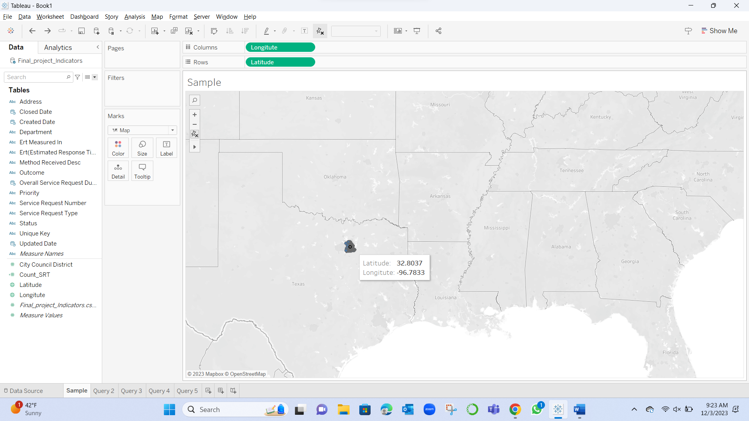

**Hive and Spark**

CREATE EXTERNAL TABLE IF NOT EXISTS Team_indicator_1

(Team_indicator_1 string,

`SERVICE_REQUEST_NUMBER` string,

`ADDRESS` string,

`CITY_COUNCIL_DISTRICT` int,

`DEPARTMENT` string,

`SERVICE_REQUEST_TYPE` string,

`ERT_ESTIMATED_RESPONSE_TIME` string,

`ERT_MEASURED_IN` string,

`OVERALL_SERVICE_REQUEST_DUE_DATE` timestamp,

`STATUS` string,

`CREATED_DATE` timestamp,

`UPDATED_DATE` timestamp,

`CLOSED_DATE` timestamp,

`OUTCOME` string,

`PRIORITY` string,

`METHOD_RECEIVED_DESC` string,

`LATITUDE` float,

`LONGITUTE` float,

`UNIQUE_KEY` string

)

ROW FORMAT DELIMITED

FIELDS TERMINATED BY ','

LINES TERMINATED by '\n'

STORED AS TEXTFILE

LOCATION '/user/tejamanikantagudla/data/Final_project_Indicators/';

Using the above query, we can create a table and import the dataset into the created table.

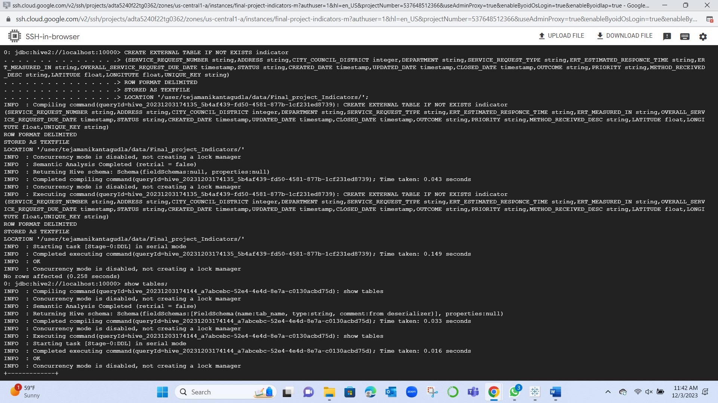

Below is the table displayed with 5 records.

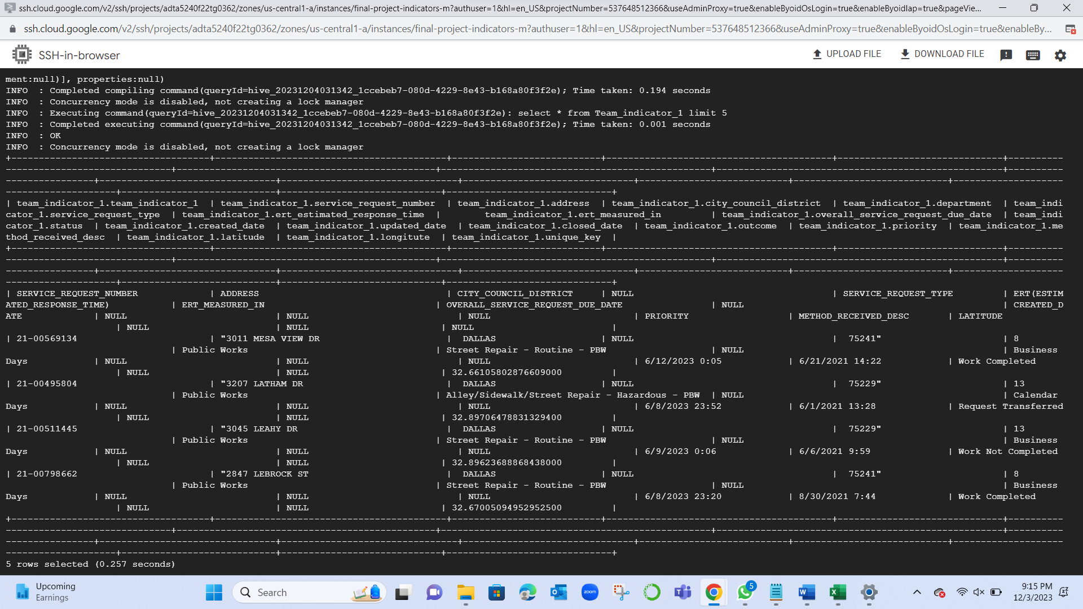

**Application used: Linux: Hive**

Spark

Select * from Team_indicator_1 Limit 5;

Displays the 5 records from the dataset.

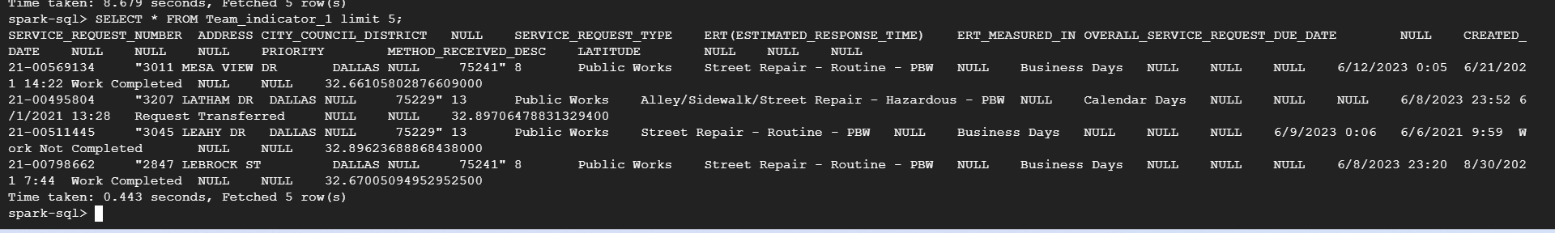

**Application used: Linux: Spark**